EM425 Assignment #7

Problem Statements

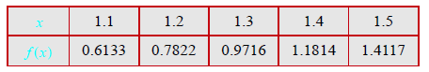1. (Based on 8.17) Write a MATLAB user-defined function that determines the first derivative of a function that is given by a set of discrete points with equal spacing. For the function name use yd = FirstDeriv(x,y). The input arguments x and y are vectors with the coordinates of the points, and the output argument yd is a vector with the values of the derivative at each point. At the first and last points, the function should calculate the derivative with three-point forward and backward difference formulas, respectively. At all other points FirstDeriv should use the two-point central difference formula. Use FirstDeriv to calculate the derivative of the function given in the following tabulated data:

Output the value of  at 

2. (Based on 8.18) Write a MATLAB user-defined function that calculates the second derivative of a function that is given by a set of discrete data points with equal spacing. For the function name and arguments use ydd = SecDeriv(x,y), where the input arguments x and y are vectors with the coordinates of the points, and ydd is a vector with the values of the second derivative at each point. For calculating the second derivative, the function SecDeriv should use the finite difference formulas that have a truncation error of  Use SecDeriv for calculating the second derivative of the function that is given by the tabulated data below:

 Output the value of  at 

3. (Based on 8.37) A radar station is tracking the motion of an aircraft. The recorded distance to the aircraft, and the angle  during a period of 60s is given in the table below. The magnitude of the instantaneous velocity and acceleration of the aircraft can be calculated by:



Determine the magnitudes of the velocity and acceleration at the times given in the table. Plot the velocity and acceleration versus time on the same plot with two different y-axes using the built-in MATLAB tool yyaxis. Calculate the derivatives using the FirstDeriv and SecDeriv functions you developed for the previous two problems.

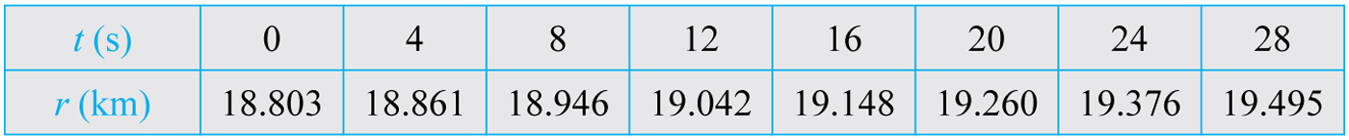

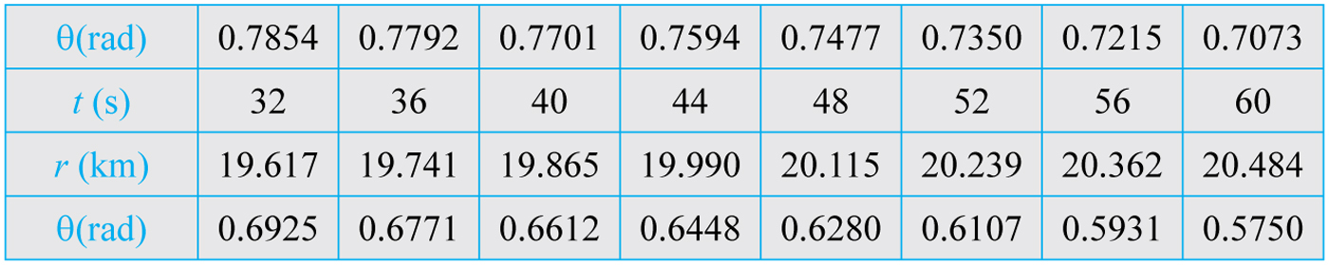

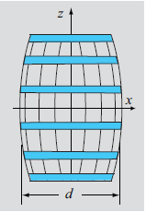4. (Based on 9.19) Write a user-defined MATLAB function for integration with the trapezoidal method of a function  that is given in a set of  discrete points. The points do not have to be spaced equally. For the function name and arguments use I=IntPointsTrap(x,y), where the input arguments x and y are vectors with the values of  and the corresponding values of respectively. The output argument I is the value of the integral.

Use the function to estimate the surface area and volume of a wine barrel. The diameter of the barrel is measured at the points provided in the table below. The surface area,  and volume,  can be determined by:

 

Output the surface area and volume of the barrel.

5. (Based on 9.20) Write a user-defined MATLAB function for integration with Simpson’s Rule of a function  that is given in a set of  discrete points that are spaced equally. For the function name and arguments use I=SimpsonPoints(x,y), where the input arguments x and y are vectors with the values of  and the corresponding values of respectively. The output argument I is the value of the integral. Use the function to compute  with tabulated data below:



Output the value of the integral in MATLAB.

6. (Based on 9.25) Write a user-defined MATLAB function for integration of a function  in the domain  with five-point Gauss quadrature. For function name and arguments use I=GaussQuad5ab(Fun,a,b) where Fun is a name for the function that is being integrated, a and b are the lower and upper bounds of the integral and I is the value of the integral. Use the function to calculate the value of the following integral:



Output the value of the integral in MATLAB.

**Solutions:**





